SIMATS ENGINEERING (SAVEETHA SCHOOL OF ENGINEERING)
Department of Computer Science and Engineering
ASSESSMENT TOOL 3 – Mock Interview
Course Code: | CSA06 | Course Title: | Design and Analysis of Algorithms
CO Assessed: | CO5 – Naturalization (BL5, BL6) | Assessment: | Assessment Tool 3 – Mock Interview
Weightage: | 30% of CIA | Total Marks: | 100
CO5 Statement: | Analyze computational problems using backtracking techniques and complexity classes such as P, NP, NP-Hard, and NP-Complete for combinatorial problem solving.
Student Name: | A M RAKESH | Reg. No.: | 192424393
Section / Batch: | AIDS/24 | Date: | 29/08/2026

Instructions to Students
• Attend the mock interview individually and answer all technical questions clearly.
• Explain the logic, algorithm design steps, and complexity analysis wherever required.
• Demonstrate understanding of backtracking, recursion, and combinatorial problem-solving approaches.
• Differentiate clearly between P, NP, NP-Hard, and NP-Complete problems with suitable examples.
• Maintain clear communication, confidence, and logical presentation throughout the interview.

Question Type | Focus Area | Questions | Marks
Mock Interview | Demonstrate problem-solving skills in backtracking techniques and complexity classes through technical discussion and algorithmic analysis. | Q1- Q15 | 100
GRAND TOTAL: |  | 100 Marks

SECTION A – Mock Interview

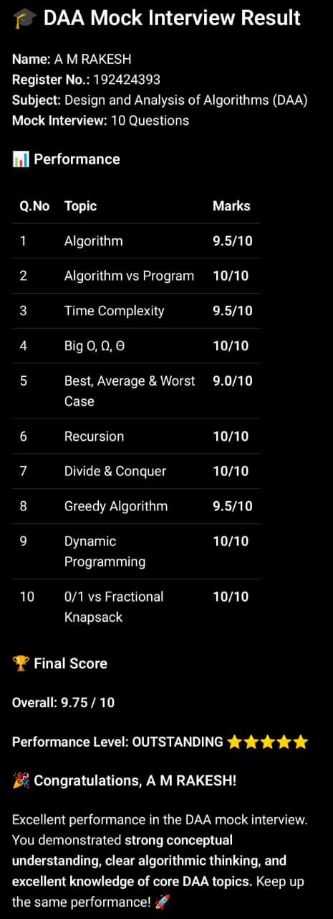

Code of Conduct
I A M RAKESH/192424393 (Name / Reg No) certify that this submission is my original work and that I have adhered to the guidelines specified for this assessment. I understand that any violation of academic integrity rules will result in disciplinary action.
Signature of the Student: 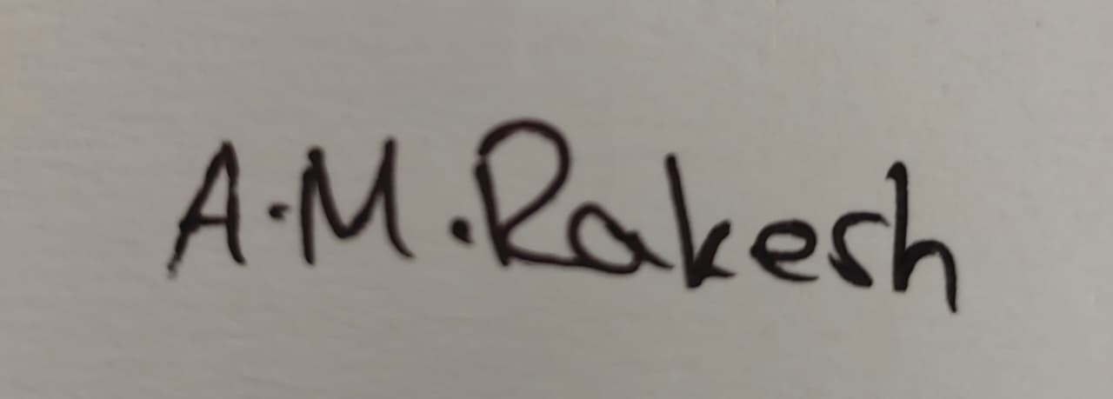
RUBRICS FOR CALCULATION
Criteria | Wt. | Level 4 – Exemplary | Level 3 – Proficient | Level 2 – Developing | Level 1 – Beginning
Technical Knowledge | 25% | Demonstrates strong and accurate subject knowledge with in-depth understanding | Shows good knowledge with minor gaps | Basic knowledge with noticeable errors | Lacks fundamental technical knowledge
Problem Solving | 25% | Solves problems logically and applies concepts effectively in real scenarios | Applies concepts with moderate accuracy | Limited problem-solving ability; requires guidance | Unable to solve or apply concepts
Analytical Thinking | 15% | Analyzes questions critically and provides well structured, logical answers | Provides reasonable analysis with some structure | Superficial or partially structured responses | No analytical thinking demonstrated
Communication | 15% | Communicates clearly, confidently, and professionally with proper terminology | Communicates well with minor hesitation | Communication lacks clarity or confidence | Unable to communicate effectively
Confidence | 10% | Displays high confidence, positive attitude, and professional behavior throughout | Shows good confidence with minor issues | Low confidence; inconsistent behavior | Lacks confidence and professionalism
Response to Questions | 10% | Responds accurately, promptly, and elaborates with relevant examples | Responds correctly but with limited depth | Partial responses; needs prompting | Unable to respond appropriately

Marks Evaluation:
Q.No. | Technical Knowledge  (25%) | Problem Solving  (25%) | Analytical Thinking  (15%) | Communication  (15%) | Confidence  (10%) | Response to Questions  (10%) | Total Marks (100)
Q1
Overall Total (100)
Faculty In-charge | Course Coordinator | Head of Department
Signature: _______________ | Signature: _______________ | Signature: _______________
Date: ___________________ | Date: ___________________ | Date: ___________________

